Improvement Support to Councils - One Public Estate

Purpose:
For information.

Summary
The One Public Estate (OPE) programme has grown since its inception as a pilot programme in 2013 working with 12 council areas, to a large national programme now involving 97% of local authorities.
This report details the growth and progress of the programme, including the recently launched £75m Brownfield Land Release

Recommendation/s
That IIB notes the progress of the One Public Estate programme.

Contact officer: Ellen Vernon
Position: Programme Director – One Public Estate
Phone no: 07464 652918
Email: ellen.vernon@local.gov.uk

Improvement Support to Councils - One Public Estate
Background
- The One Public Estate (OPE) programme was established in 2013, and is jointly delivered by the LGA and the Cabinet Office through a blended team, part working in the LGA and part in the Office of Government Property (OGP), part of the Cabinet Office. Since 2017 the Ministry of Housing, Communities and Local Government (MHCLG) have been an additional sponsoring partner.

- The OPE programme aims to support public bodies to identify and release surplus land, with a particular emphasis on repurposing surplus public land for housing and economic uses.

- The programme provides practical and technical support, alongside revenue and capital funding, to public bodies. There are two types of funding offer:

  - OPE – revenue funding to support partners to work collaboratively on joint projects exploring options to improve efficiency in the public estate, and to release or repurpose surplus public land
  - LRF (Land Release Fund) – capital funding to bring surplus local authority land that is suitable for housing to a point of viability and delivery

- To date the programme has administered eight rounds of funding totalling c.£57m of revenue funding (OPE) and c.£65m of capital funding (LRF).

- The One Public Estate (OPE) programme opened the £75m Brownfield Land Release Fund for bids on April 19th.

- The programme continues to support both OGP, and MHCLG, to understand the needs and opportunities related to public land, and to explore, develop and design intervention approaches.

One Public Estate Programme Structure
- One Public Estate operates through a structure of 72 local OPE partnerships. Local authorities act as the accountable bodies for these OPE partnerships, convening a variety of public bodies in the locality in order to collaborate on public property matters.

- The public bodies involved alongside local authorities vary by locality, depending on property ownerships and local ambitions, but typically involve blue light bodies, health bodies, and central government departments with a local presence (DWP, MOJ, MOD et al).

- Each OPE partnership sets a programme of work to review local public property needs collaboratively, in order to identify opportunities for co-locations, public service hubs, and other efficiencies, and with the aim of releasing surplus public land for housing and regeneration purposes. Partners benefit from capital receipts and revenue savings where surplus land can be repurposed, as well as improved public service delivery from co-locating public services. Local authorities also benefit from the ability to repurpose public land to meet local housing needs.

- In addition, the network of OPE partnerships plays a helpful role connecting central government to local areas. Over the last year this has included:

  - supporting response and recovery in relation to the pandemic: for example, supporting property searches for response infrastructure
  - providing intelligence to the IPA (Infrastructure and Project Authority) about the public sector construction pipeline
  - providing early views to MHCLG on policy direction in relation to public land.

One Public Estate Support
- The One Public Estate offer includes financial support, peer support, plus practical and technical advice and brokering from the OPE team.

- OPE provides revenue support to early-stage property projects which involve an element of collaboration between local and central government bodies. OPE grants typically fund feasibility studies, masterplans and other technical studies, plus local authority capacity.

- To date the programme has administered eight rounds of OPE revenue funding totalling c.£57m and supporting c.700 projects.

- LRF provides capital support, to local authorities only, typically funding the capital works that are required to bring a local authority owned potential housing site to a point of viability, and therefore deliverability. Typical works funded include: abnormal costs related to contamination, demolition of obsolete buildings, abnormal utilities costs, highways requirements and so forth.

- To date the programme has administered two rounds of LRF capital funding totalling c.£65m and supporting c.140 projects.

One Public Estate Delivery
- To the end of November 2020, the OPE programme has enabled the delivery of:

  - over £456m in capital receipts
  - over £88m in revenue savings to benefit public bodies
  - the release of surplus public land for over 19,000 homes
  - the creation of over 31,500 jobs.

- Equally as valuable have been the softer benefits. These include:

  - enabling local authorities to have some control over the supply of land for housing
  - the ability to support SME’s and local supply chains
  - enabling local authorities to connect and engage with harder to reach parts of government
  - the ability to share problem solving and best practise between councils and other public bodies
  - the ability to link public property to support place agendas – for example town centre regeneration.

- Case studies of OPE and LRF supported projects are attached at Appendix A.

Activity in 2021/22
- The OPE programme launched the Brownfield Land Release Fund (BLRF) on April 19th. The BLRF is funded by MHCLG, and comprises £75m available as follows:

  - £50m capital grant for brownfield land release
  - £25m capital grant for self and custom-build schemes

- Brownfield land - £50m capital funding is available to support local authority land release for housing on brownfield land, targeting small sites with viability issues which have prevented the release of land to date. The fund design is largely similar to previous rounds of LRF, with the exceptions that:

  - there is greater scope for projects with a benefit cost ratio (BCR) threshold between 1.0 and 1.5 to be supported, where evidence can also be provided regarding non-monetised benefits (for example visual amenity benefits from developing a brownfield site). The intention is to allow a greater number of applications to come forward in areas where residential land values are lower and therefore help achieve one of the fund’s strategic aims to level-up
  - the fund will be open to councils across England, apart from those Mayoral Combined Authority (MCA) areas who have already benefited from the £400 million brownfield fund

- Self and custom-build schemes - £25m capital funding is allocated to support local authority land release for self and custom-build projects on both greenfield and brownfield sites. Self and custom-build is a growing sector, and this funding will help address the lack of supply of serviced self and custom-build plots.

- The OPE programme is currently holding workshops with local authorities to provide briefings on the detail of the funds, plus advice on applying. The BLRF application window closes on 2nd June, with project assessments and funding awards occurring over the summer.

- The LGA continues to work with OGP and MHCLG partners through the OPE programme on exploring and developing further interventions and approaches to support housing delivery and public land efficiency.
Issues
- There are no specific issues to raise in relation to the OPE programme.
Implications for Wales
- None – the OPE programme only covers English local authority areas. The OPE programme has previously engaged with Welsh Government colleagues to share experiences and learnings.
Equalities implications
- Positive –

  - the OPE programme seeks to support property projects which in general terms improve accessibility to public services for all, and which support local authorities’ to best meet diverse housing needs where the market is unlikely to meet these
  - the criteria to be assessed as part of the current BLRF application round include the degree to which the Public Sector Equality Duty is met by proposed schemes (PSED is 5% of the available score)
  - the OPE programme seeks to ensure EDI aims are met operationally, for example through recruitment practises, providing subtitles on video formats and so forth.
Financial implications
- The OPE programme is delivered by the LGA in partnership with Cabinet Office via a contract. The current contract encompasses the period April 2019 through to March 2022. A contract for the period April 2022 onwards will be renegotiated with Cabinet Office during Q1/Q2 2021/22.
Next steps
- The OPE programme continues to work with OPE partnerships to support previously funded property projects through to delivery.

- The OPE programme is exploring options to work more closely with private sector stakeholders, in particular the scope to introduce commercial income to support the programme deliver its aims.

- The programme is also exploring other areas where public land and OPE’s collaboration principles might play a role in helping resolve public policy challenges.
- From an operational perspective, the OPE programme is in the process of expanding the OPE team to ensure the successful achievement of the BLRF aims, and future programme aims.

APPENDIX A – ONE PUBLIC ESTATE and LAND RELEASE FUND CASE STUDIES
One Public Estate Phases 1-7
The York Central Development

- Planning permission approved for the infrastructure work that will deliver 2500 homes, 6500 jobs and 1.2m sq ft commercial development space.
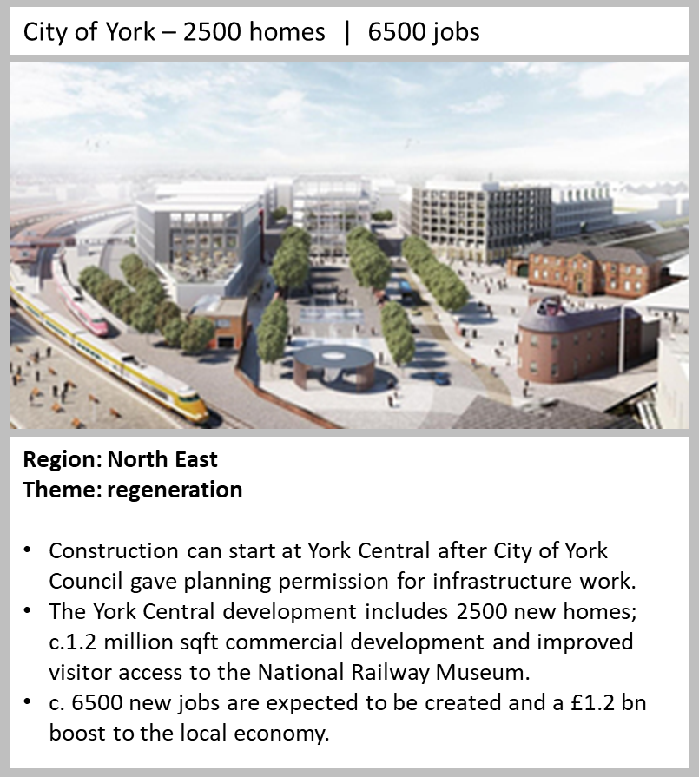

Chatham, Medway
- The development at White Road has progressed to 20 MMC homes on site and a capital receipt of £2.8m has been reported.
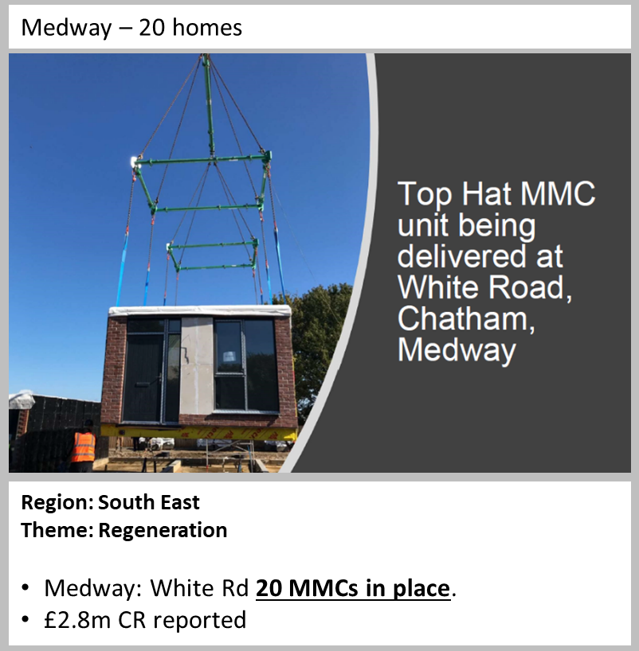

Wareham relocatable housing

- 18 homes have been delivered at the community-based project through a relocatable housing solution that supports affordable key worker accommodation.

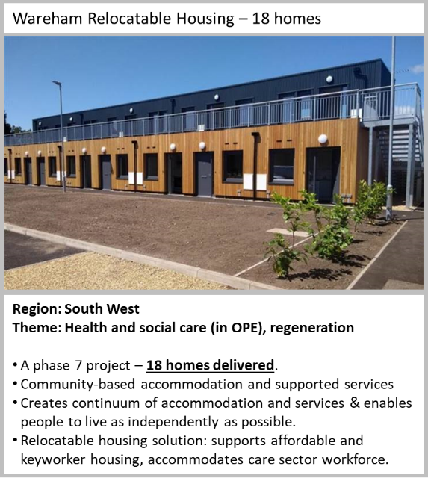

Worcestershire JPV integrated public services

- 5 sites sold resulting in a capital receipt of £7m and reduced running costs of £9m.

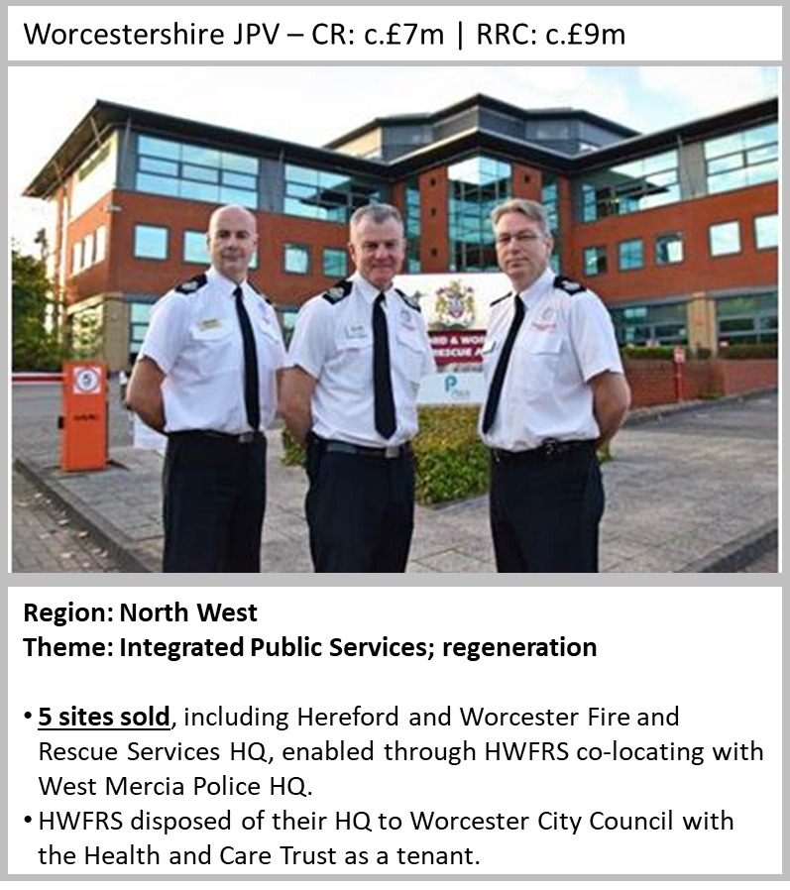

Hounslow Cavalry Barracks

- Development partnership with Inland Homes agreed, a key milestone for a project due to deliver in excess of 1000 new homes and £50m capital receipt.
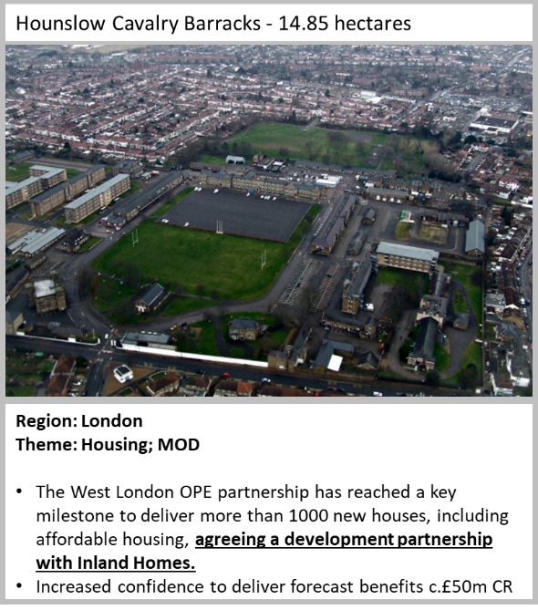

Land Release Fund Round 1

Hertfordshire OPE Partnership - Stevenage - 30 new homes over 2 sites

- Gresley Way - 15 new homes completed. Re-named Blackwell Close, this scheme comprises 14 homes for affordable rent and 1 for private sale. Stevenage District Council has collaborated with Hertfordshire County Council to let a proportion of the properties to clients with higher support needs, with properties designed to ensure they best met the needs of this client group.

- Burwell Court - 15 new homes completed. 15 one and two bed apartments which are entirely for social rent. The scheme was built on a derelict pub site that was a hot spot for anti-social behaviour, and has transformed the local area.

- Kenilworth Close - Construction started in October 2020 for the delivery of 236 homes by January 2024.

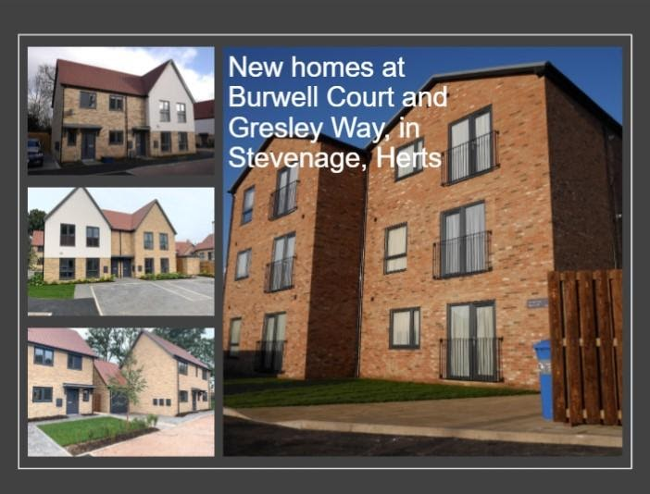

Plymouth OPE Partnership - Corporate Asset Release Project - 24 new homes

- St Budeaux Library site - 24 new homes completed. All are affordable homes, and four are wheelchair accessible. The site will eventually be part of a mixed development.

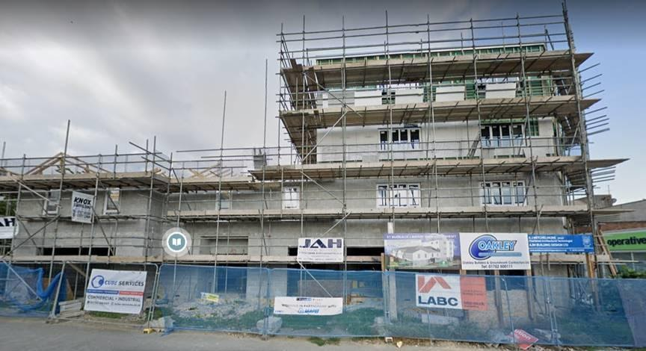

Essex OPE Partnership - Rochford - 14 homes construction start

- Rocheway and Millview sites - September saw construction start on 14 new homes in Rochford. Road infrastructure and drainage work commenced at Rocheway for the first phase of housing. This initial phase will deliver 14 homes, with a procurement exercise underway for the second phase (a further 60 homes).
